### Laravel Validation

Since forms validation is an essential part of any web applications to ensure that only valid data is saved in the database and in a certain format or length, Laravel has “Validation” library to make this part simple and easy to implement [1].

*FacultyCooperative* website has many forms to validate their input fields before completing the action process of each form.

Validation of *Register from*:

* 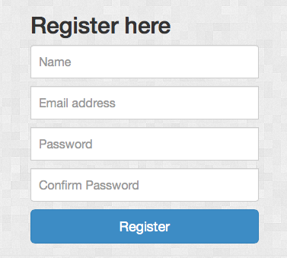All fields are required in this form.
* Email field is must be unique.

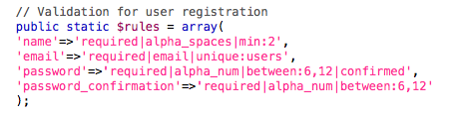

Validation of *login from*:

* All fields are required in this form.

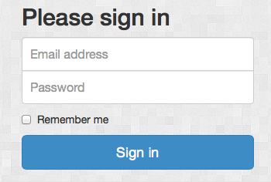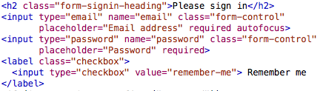

Validation of *editProfile form:*

* 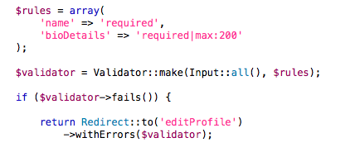name and bioDetails fields are required.

Validation of *createVenture form:*

* Title of the venture is required.

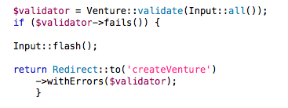

* 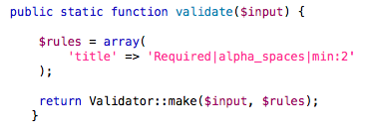In this part, the *validate* method called from *model/venture.php*

Validation of *sendMessage form:*

* subject and message fields are required.

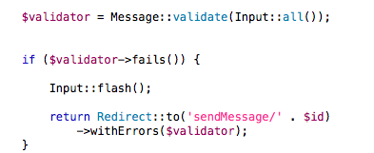

* In this part, the *validate* method called from *model/Message.php*

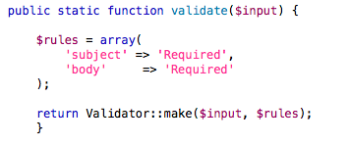

Finally, all forms have their validation part now and all of them are tested and work properly as expected.

[1] http://laravelbook.com/laravel-input-validation/